Binary Search Trees
Implement BST Operations
You are given a skeleton, in which you will find implemented the following operations:
void Insert(T) – Recursive implementation
void EachInOrder(Action<T>) – In-Order traversal
bool Contains(T) – Iterative implementation
BST<T> Search(T) – Returns copy of the BST
IEnumerable<T> Range(T, T) – Returns collection with the elements found in the BST. Both borders are inclusive.
DeleteMin() – Deletes the smallest element in the tree. Throws exception if the tree is empty.
You will need to implement the rest of the operations, that are defined below:
C# Method | Java Method | Return Type | Exception C#/Java
DeleteMax() | deleteMax() | void | C# - InvalidOperationException  Java -IllegalArgumentException
Count() | size() | int
Rank(T) | rank(T) | int
Select(int) | select(int) | T | C# - InvalidOperationException
Ceiling(T) | ceiling(T) | T | C# - InvalidOperationException
Floor(T) | floor(T) | T | C# - InvalidOperationException
Delete(T) | delete(T) | void | C# - InvalidOperationException  Java - IllegalArgumentException

Delete Max
Implement a method which deletes the max element in a BST (Binary Search Tree). If the tree is empty it should throw exception. The logic is similar to the DeleteMin() method, but you need to traverse the tree to the right.
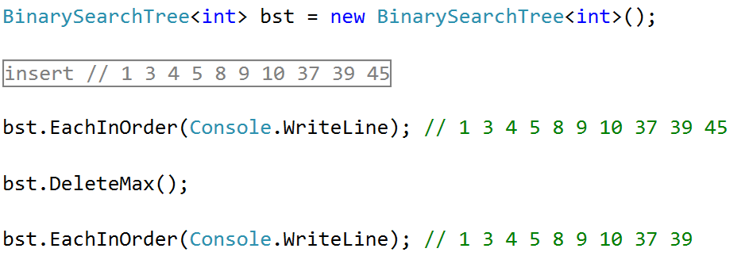

Count
Implement a method which returns the count of elements in the BST.
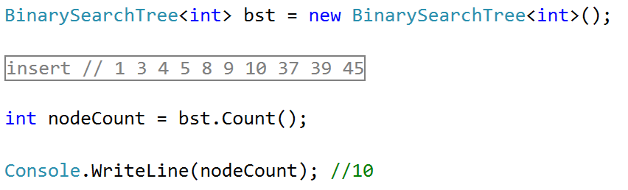
Hints
In order to implement the count, we will create a new field in our Node class:
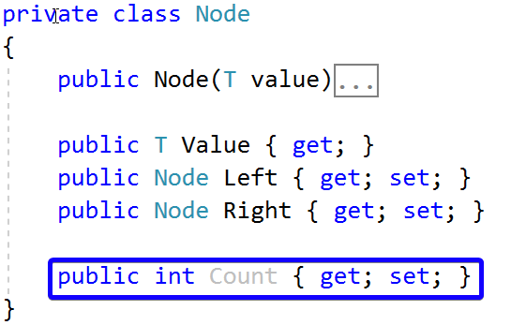
Now we can create new method Count(Node), which will recursively find the count of elements:
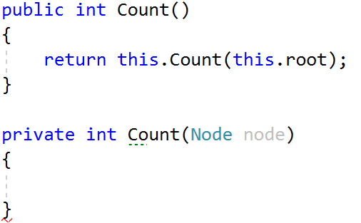
If our current node is null, we will return 0. Otherwise, we will return the count of our current node:
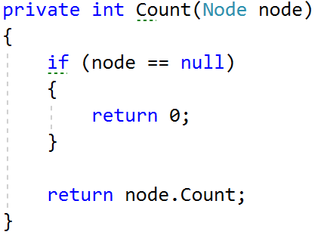
Now we only have to modify our Insert() method. It will set the count of elements of our new node to the count of its children nodes plus itself:
Next, we need to find a way to update the recalculate the count for each node when DeleteMin() is invoked. One way would be to change the DeleteMin() implementation to be recursive:
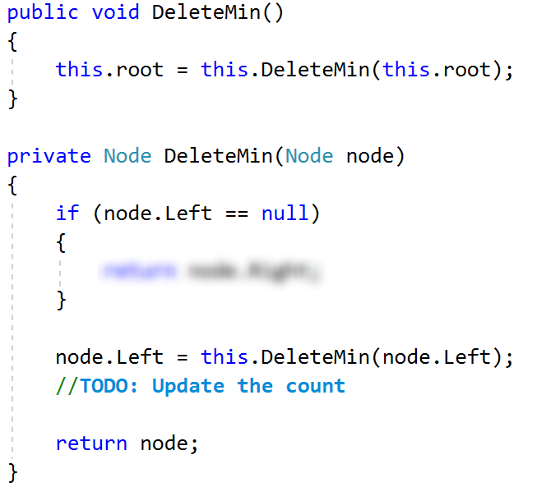
What will happen if our tree is empty and we call DeleteMin()? Fix it. Our count is ready.

Rank
Implement a method which returns the count of elements smaller than a given value.
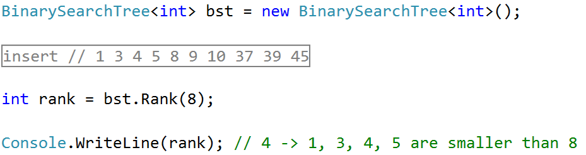
Hints
Create a new recursive method that will return 0 if the node is null:
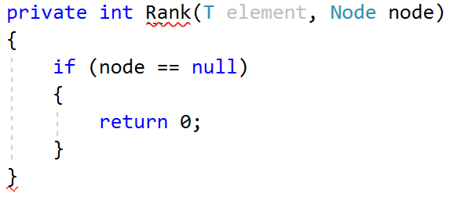
Then, we need to compare the element with the value of the node we are currently looking at. If the element is smaller, we can go to the left. If its larger, we need to get the count of the left elements and go to the right. If we find the element, we will return the count of elements, smaller than it.
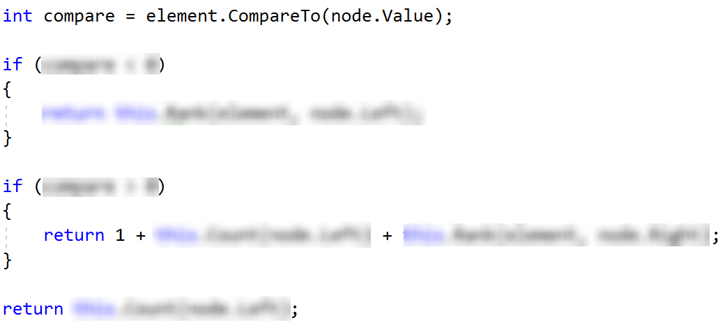
You can try it out, it should work as expected.
Select
Implement a method which accepts a number (n) and returns the first element which has exactly n elements smaller than it. Use the logic from Count() and Rank() to implement it.
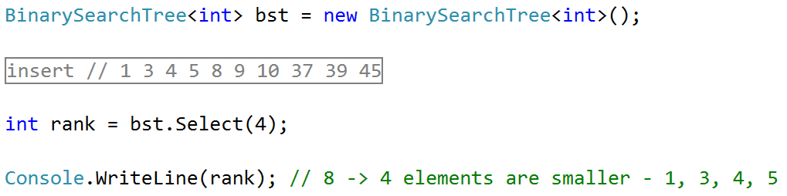
Floor
Implement a method which finds (returns) the nearest smaller value than given in the BST. This operation is similar to DeleteMin().
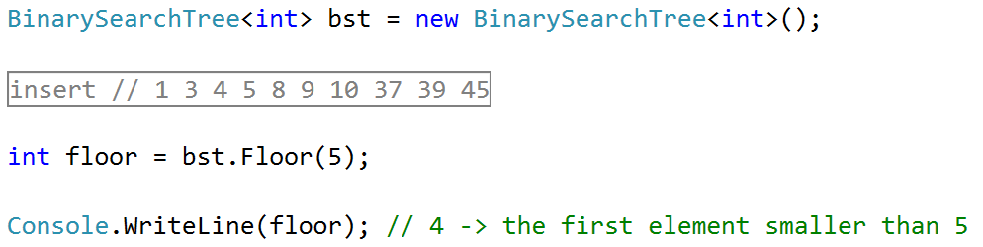
Ceiling
Implement a method which finds (returns) the nearest larger value than given in the BST. This operation is similar to Floor() and DeleteMax().
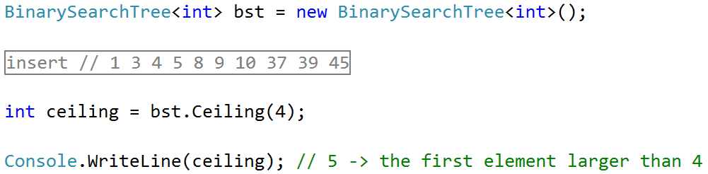
Delete*
Implement a method which deletes a node with given value.
